**Lecture | CRM Analytics - RFM model**

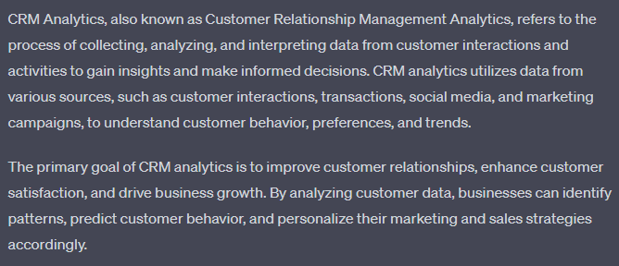

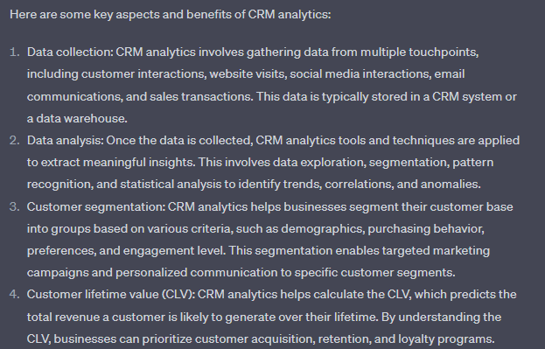

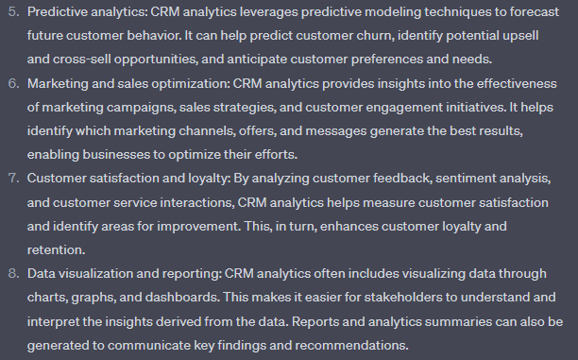

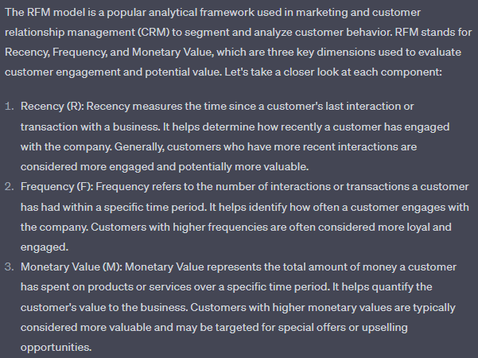

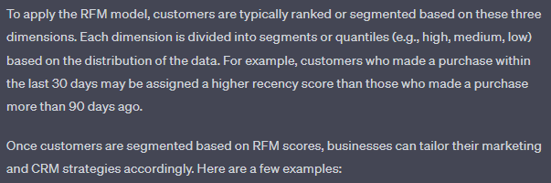

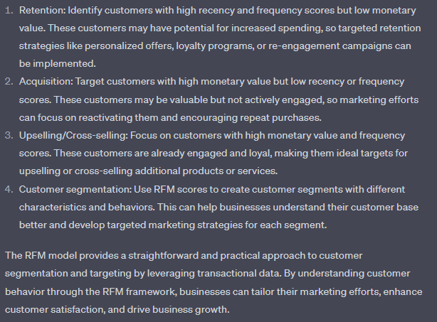

**Q1.**

Which of these seems to be the correct RFM value for a low spending, old customer who hasn’t purchased anything for a long time? Note: Ratings are on a scale of 1 (low) to 5 (high).

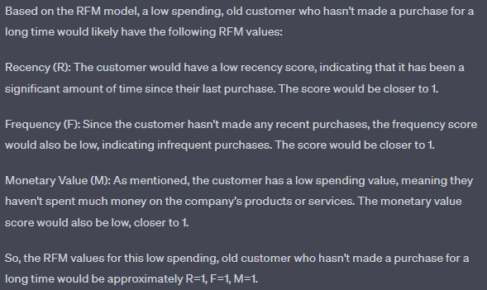

**Q2.**

